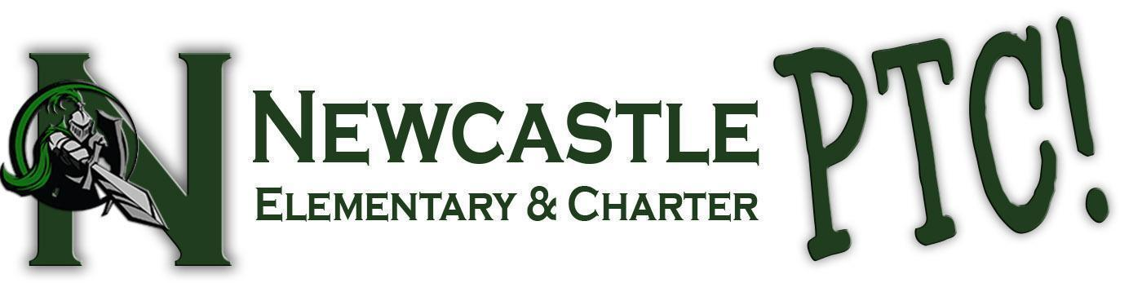

Sponsorship/Donation Opportunity
Tax Exempt Id No: 94-2549718
School Year 2022-2023

Dear Valued Business,

The Newcastle Parent Teacher Corporation (Newcastle PTC) is a non-profit serving Newcastle Elementary and Newcastle Charter School’s K-8th grade students.
We provide monetary and volunteer support for classrooms and programs, including but not limited to field trips, enrichments, playground equipment, information technology, and campus improvement. The funds generated from our annual fundraising events are used for the direct benefit of all of our students and their teachers. We rely on the support of our community through donations like yours to make this possible.
This year we are excited to announce our 2nd Annual all-school Color Run. This free event will be held on March 25th on the school campus, and all students at Newcastle Elementary will participate. This is our largest fundraiser of the year and wouldn't be possible without donors like you. The Newcastle PTC is a 501(3)(c) non-profit organization, and donations to this event are tax deductible. Please consult your tax professional for further information. Thank you for your support of our students, our school, and their education!

Respectfully,

Color Run Planning Committee
Newcastle Parent Teacher Corporation

Contact info: ptcnewcastle@gmail.com Phone: 916-765-8591
Newcastle Parent Teacher Corporation, 8951 Valley View Drive, Newcastle, CA 95658
YES!
Our Business would like to sponsor the 2nd Annual Color Run for the following amount $___________________
OR
I would like to donate the following items:
Item(s) and Description(s) Value
- Apples $_______
- Cookies $_______
- Bottle Water $_______

Contact Person:
______________________________________________________________________________
Mailing Address: _______________________________________________________________________________
Phone Number and or Email Address: ________________________________________________________________________________
Please complete and return with your check or gift card, made payable to Newcastle PTC
Newcastle Parent Teacher Corporation,
8951 Valley View Drive, Newcastle, CA 95658

If you have donated food or perishable items, any donated items will be picked up at your business location on March 24th, 2023.

